Regulations:
A18

H.T No

Sreenidhi Institute of Science and Technology
(An Autonomous Institution)
Code No: 7BC03 Date: 11-Jan-2020 (FN)

B.Tech I-Year I-Semester External Examination, Jan-2020 (Supplementary)
ENGINEERING MECHANICS (ME)

Time: 3 Hours Max.Marks:70

Note: a) No additional answer sheets will be provided.
b) All sub-parts of a question must be answered at one place only, otherwise it will not be valued.
c) Missing data can be assumed suitably.

Part - A Max.Marks:20

Answer all QUESTIONS.

1. | State Lami’s theorem with a neat sketch? | [2M]
2. | What are the assumptions in developing the theory of perfect frames. | [2M]
3. | Define the terms: (i) Friction; (ii) Coefficient of friction. | [2M]
4. | State Perpendicular axis theorem. | [2M]
5. | Explain the difference between Rectilinear and Curvilinear motion. | [2M]
6. | State and explain work-energy theorem. | [2M]
7. | Define principle of transmissibility. | [2M]
8. | State and explain the principle of Virtual work. | [2M]
9. | State D’Alembert’s principle. | [2M]
10. | What are the steps followed while drawing free body diagrams? | [2M]
Part – B Max.Marks:50
ANSWER ANY FIVE QUESTIONS. EACH QUESTION CARRIES 10 MARKS.

11. | a) | A system of four forces acting on a body is as shown in Fig. 1 Determine the resultant.  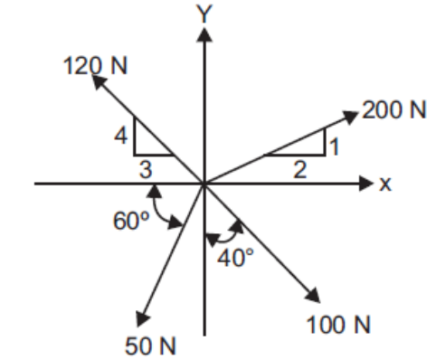  Fig. 1 | [5M]
 | b) | A system of loads acting on a beam is shown in Fig. 2. Determine the resultant of the loads.  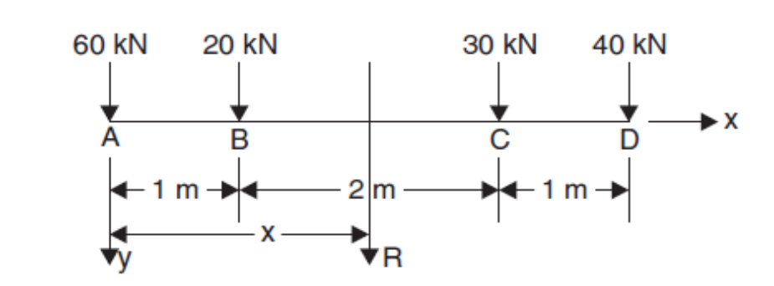  Fig. 2. | [5M]
12. | a) | Determine the forces in all the members of the trusses shown in Fig. 3  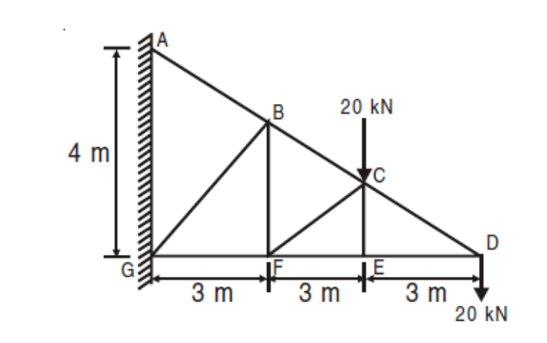  Fig. 3 | [7M]
 | b) | Differentiate between perfect, deficient and redundant trusses. | [3M]
13. |  | Determine the force P required to start the wedge as shown in Fig. 5. The angle of friction for all surfaces of contact is 15°.  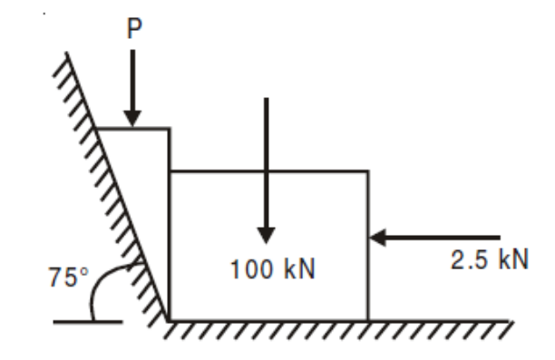  Fig. 5. | [10M]
14. |  | The cross-section of a rectangular hollow beam is as shown in Fig.6. Determine the polar moment of inertia of the section about centroidal axes.  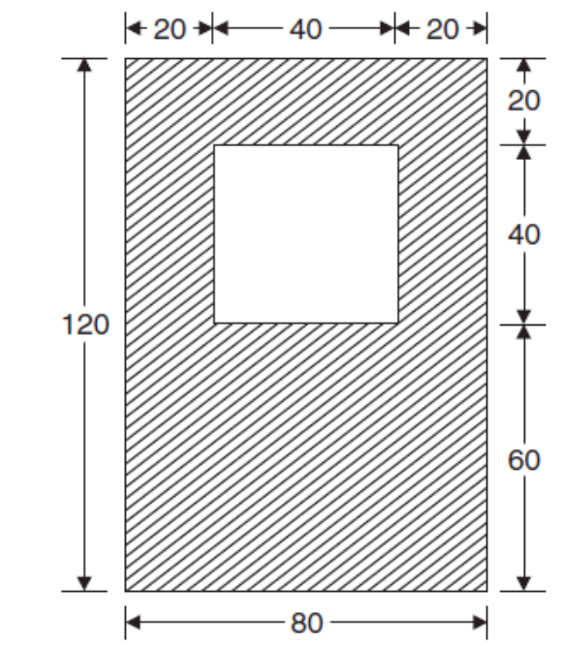  Fig.6. | [10M]
15. | a) | A string is wound around a pulley of diameter of 0.2m. One of its ends is tied to the pulley and the other to a weight hanging freely. The weight falls a distance of 4m from rest in 3s.Find the angular acceleration and final angular acceleration of the pulley. Also determine the total distance through which the weight should fall so that the velocity of the pulley will be 400rpm. | [5M]
 | b) | A stone is dropped into a well while splash is heard after 4.5 s. another stone is dropped with a initial velocity of v ms⁻¹ and the splash is heard after 4s. If the velocity of sound is 336ms⁻¹. Determine the initial velocity of the second stone. | [5M]
16. |  | Determine the acceleration of the system of blocks shown in Fig.7 Assume the pulleys to be massless and frictionless.  Take m1 = 8kg, m2= 2 kg and m3= 3 kg. Also, determine the tension in the strings connecting the blocks.  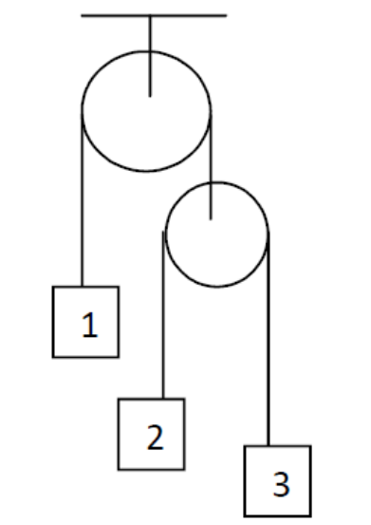  Fig.7 | [10M]
17. | a) | Two cylinders of diameters 100 mm and 50 mm, weighing 200 N and 50 N, respectively are placed in a trough as shown in Fig. 8 Neglecting friction; find the reactions at contact surfaces 1, 2, 3 and 4.  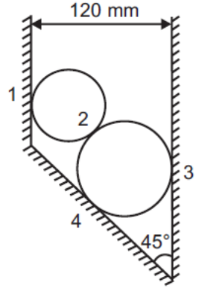  Fig. 8 | [5M]
 | b) | Derive the expression for the centroid of a triangle from first principle | [5M]
18. | a) | State and prove  (i) Perpendicular axis theorem  (ii) Parallel axis theorem of moment of inertia | [4M]
 | b) | Express the acceleration of a particle in tangential and normal components. | [3M]
 | c) | State the advantage of energy and momentum methods in the analysis of plane motion of rigid bodies | [3M]
-- 00 -- 00 –

